EXPERIMENT-16:
Aim: To develop an online complaint management system that enables users to register complaints, track complaint status, provide feedback, and facilitate efficient complaint resolution by officers and administrators.
Code:
<!DOCTYPE html>
<html lang="en">
<head>
<meta charset="UTF-8">
<meta name="viewport" content="width=device-width, initial-scale=1.0">
<title>ComplainEase</title>

<link href="https://cdn.jsdelivr.net/npm/bootstrap@5.3.3/dist/css/bootstrap.min.css" rel="stylesheet">

<style>
body{
font-family:Arial,sans-serif;
background:#f4f6f9;
}
.hero{
background:linear-gradient(to right,#007bff,#00c6ff);
color:white;
text-align:center;
padding:80px 20px;
}
.section{
display:none;
padding:20px;
}
.active{
display:block;
}
.footer{
background:#212529;
color:white;
text-align:center;
padding:15px;
margin-top:20px;
}
.card{
margin-bottom:20px;
}
</style>
</head>

<body>

<nav class="navbar navbar-expand-lg navbar-dark bg-dark">
<div class="container">
<a class="navbar-brand" href="#">ComplainEase</a>

<div>
<button class="btn btn-outline-light btn-sm m-1" onclick="showSection('home')">Home</button>
<button class="btn btn-outline-light btn-sm m-1" onclick="showSection('complaint')">Complaint</button>
<button class="btn btn-outline-light btn-sm m-1" onclick="showSection('status')">Status</button>
<button class="btn btn-outline-light btn-sm m-1" onclick="showSection('officer')">Officer</button>
<button class="btn btn-warning btn-sm m-1" onclick="showSection('admin')">Admin</button>
</div>
</div>
</nav>

<!-- Home -->
<div id="home" class="section active">
<div class="hero">
<h1>ComplainEase</h1>
<p>Register and Track Complaints Online</p>
</div>
</div>

<!-- Complaint -->
<div id="complaint" class="section container">

<h2>Post Complaint</h2>

<input type="text" class="form-control mb-3" placeholder="Complaint Title">

<select class="form-control mb-3">
<option>Select Category</option>
<option>Road Issue</option>
<option>Water Supply</option>
<option>Electricity</option>
<option>Public Service</option>
</select>

<textarea class="form-control mb-3" rows="4"
placeholder="Complaint Description"></textarea>

<input type="text" class="form-control mb-3"
placeholder="Google Map Location">

<input type="file" class="form-control mb-3">

<button class="btn btn-primary"
onclick="alert('Complaint Submitted Successfully!')">
Submit Complaint
</button>

</div>

<!-- Status -->
<div id="status" class="section container">

<h2>Complaint Status</h2>

<table class="table table-bordered">
<tr>
<th>Complaint ID</th>
<th>Issue</th>
<th>Status</th>
</tr>

<tr>
<td>C101</td>
<td>Water Leakage</td>
<td>In Progress</td>
</tr>

<tr>
<td>C102</td>
<td>Street Light Issue</td>
<td>Resolved</td>
</tr>
</table>

</div>

<!-- Officer -->
<div id="officer" class="section container">

<h2>Officer Dashboard</h2>

<div class="card p-3">

<ul>
<li>View Complaints</li>
<li>Update Complaint Status</li>
<li>Upload Proof of Work</li>
<li>Contact User</li>
<li>Generate Reports</li>
</ul>

</div>

</div>

<!-- Admin -->
<div id="admin" class="section container">

<h2>Admin Dashboard</h2>

<div class="card p-3">

<ul>
<li>Create Officer Account</li>
<li>Delete Officer Account</li>
<li>Manage Users</li>
<li>View All Complaints</li>
<li>Change Passwords</li>
<li>Manage System Features</li>
<li>View Officer Accounts</li>
<li>Generate Reports</li>
</ul>

</div>

</div>

<div class="footer">
© 2026 ComplainEase Complaint Management System
</div>

<script>

function showSection(id)
{
document.querySelectorAll('.section')
.forEach(section =>
section.classList.remove('active'));

document.getElementById(id)
.classList.add('active');
}

</script>

</body>
</html>

Output:
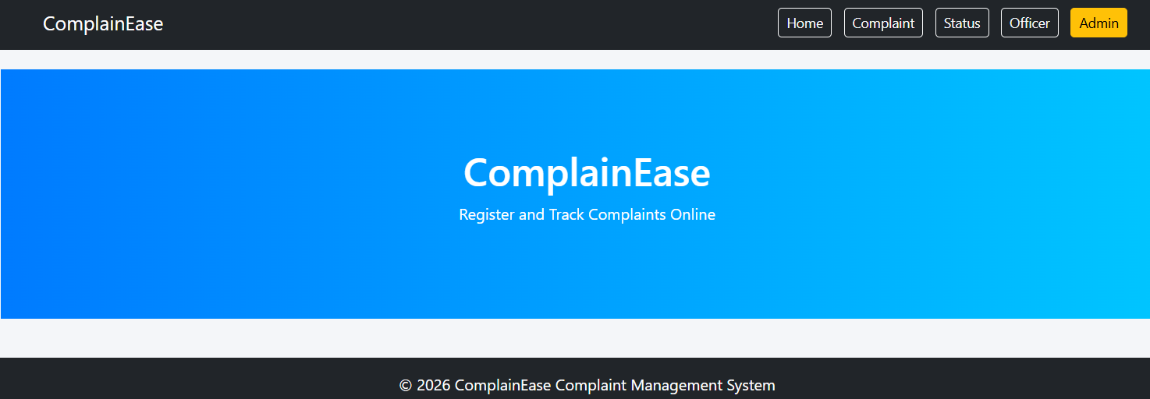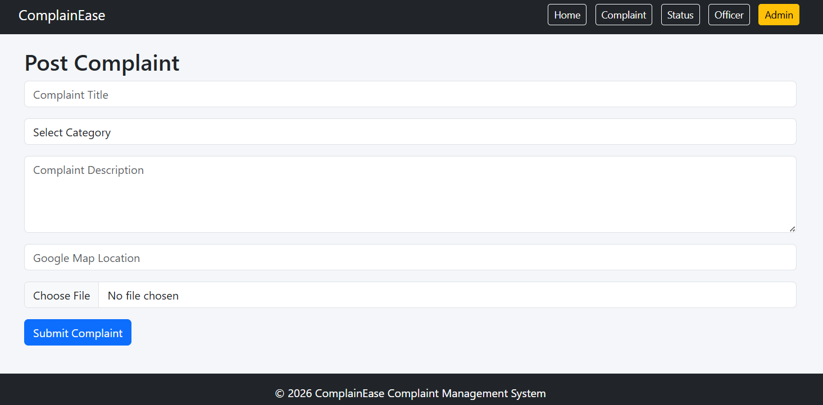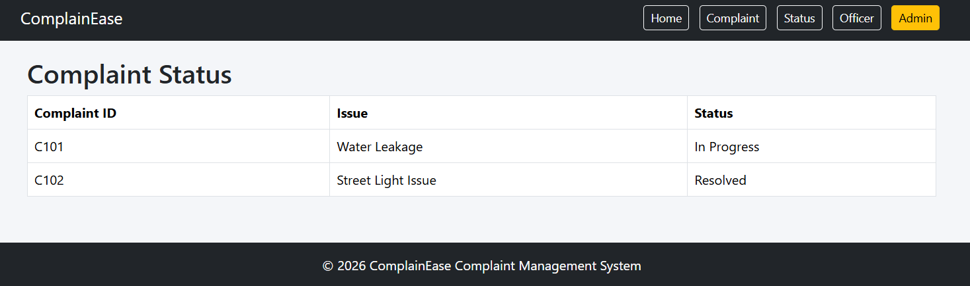

EXPERIMENT-17:
Aim: To develop an online insurance management system that allows users to compare policies, purchase insurance, manage premiums, receive renewal alerts, and file claims through a secure web platform.
Code:
Output:

Experiment-18:
Aim: To develop an online Flowers and Gifts Shopping System that allows customers to browse products, place orders, schedule deliveries, make secure payments, and track orders through a user-friendly web application.
Code:
Output:

Experiment-19:
Aim: To develop an online marketplace for buying and selling second-hand products, enabling users to create listings, search items, manage transactions, and securely connect buyers with sellers.
Code:
Output:

Experiment-20:
Aim: To develop an online Toll Payment System that enables users to purchase toll passes, make advance toll payments, generate QR codes, manage e-wallets, and verify toll transactions efficiently, reducing waiting time at toll plazas.
Code:

Output:

